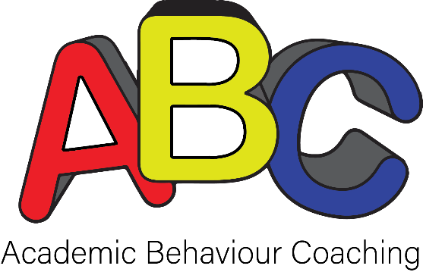

Reward Token Tracker

Student Name: Coach’s Name:

Award/Goal (within $ range and approved by parent/guardian) | Date and amount awarded (recorded each session): |  |  |  | Running Total: | Amount Needed to Reach Goal (in tokens and sessions):

